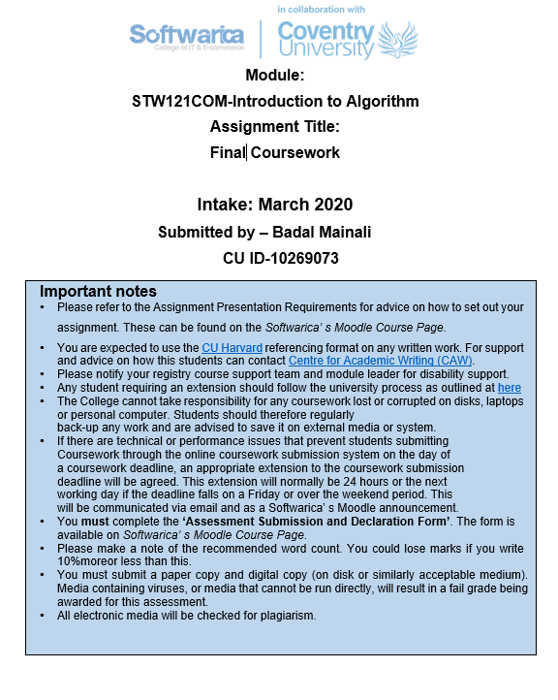

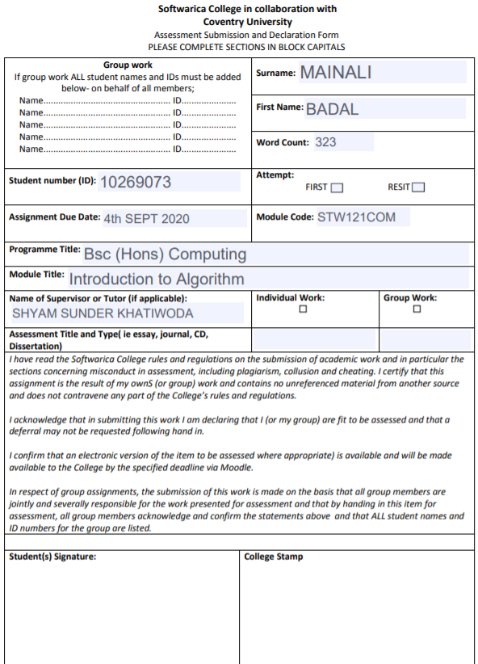

Table of Contents

**Introduction** 4

**Login** 5

**Register** 12

**Main** 19

**Employee:** 23

**Connection** 45

**Employee Model Class** 48

**Tea Model Class** 51

**Test Employee** 53

**Test Tea** 55

**Test Database** 56

**Test Sort** 58

**Conclusion** 59

**References** 59

Git link=https://github.com/softwarica-github/final-assignment-badalmainali.git

Task One

# **Introduction**

This is final coursework of Introduction to Algorithm and in this coursework an application software for Danphe Factory is made. Since Danphe factory is using papers to store information of employee and that was not so secured and reliable. It was not using any digital way of storing data. So this application will help Danphe factory to manage every activity in digital way. It will have admin login facility with good authentication also admin registration. It will also have managing employee by adding, updating and deleting employee also helps in searching and sorting employee. Tea Leaves can also be managed in same way. Tkinter and MySQL are used for making this application with use of Pycharm and Workbench.

**Task Two:**

# **Login**

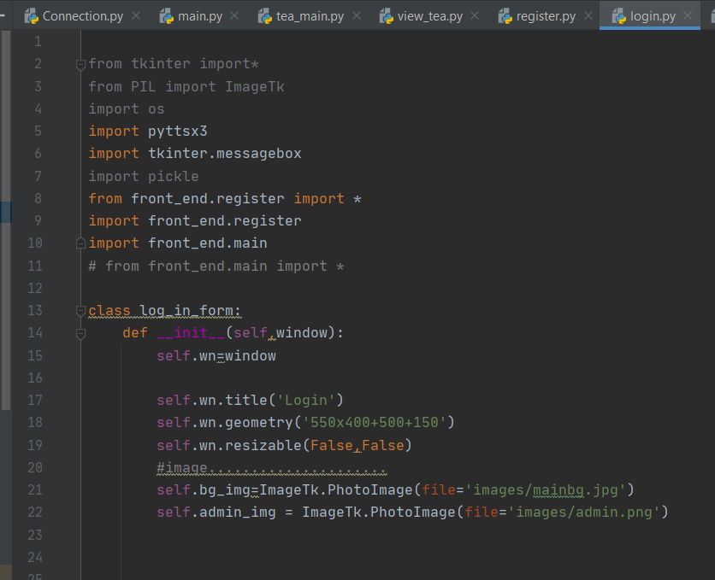

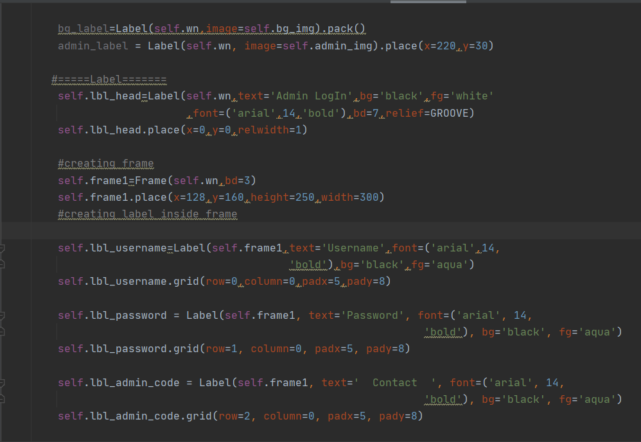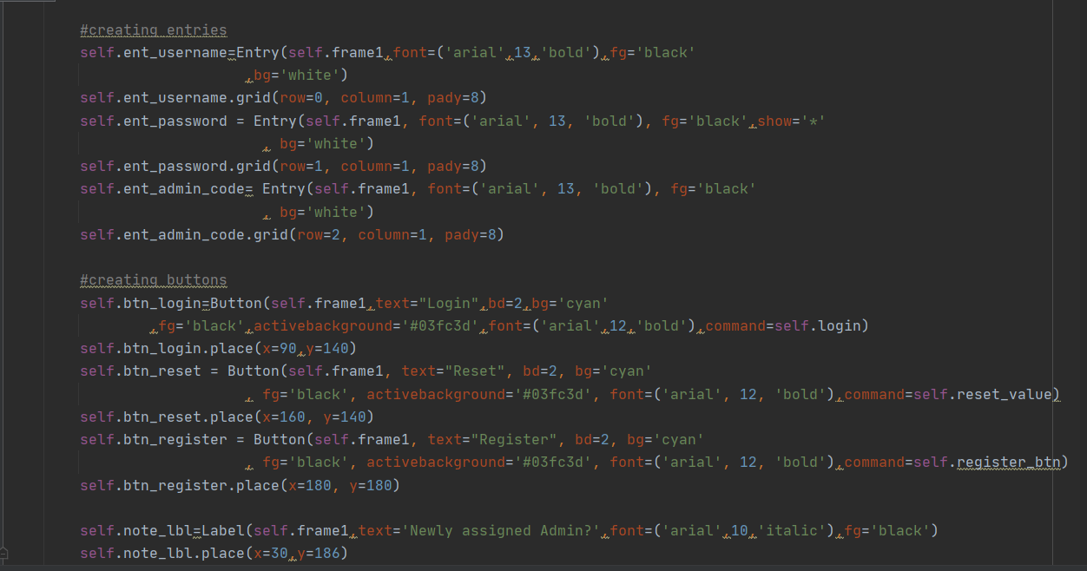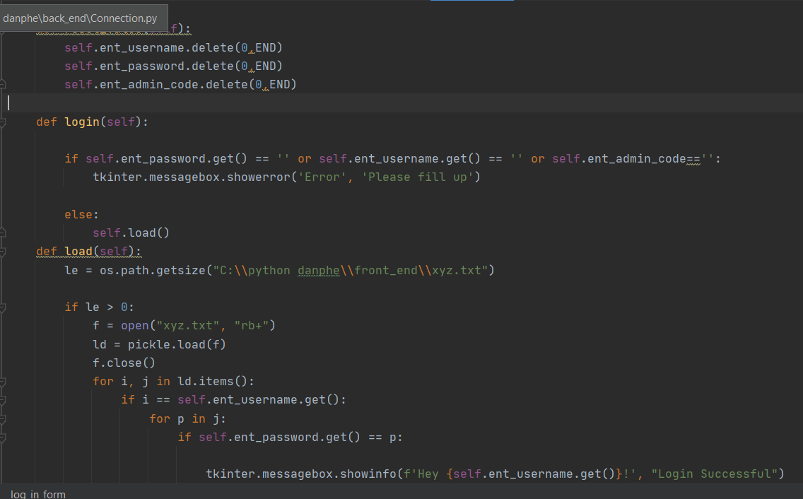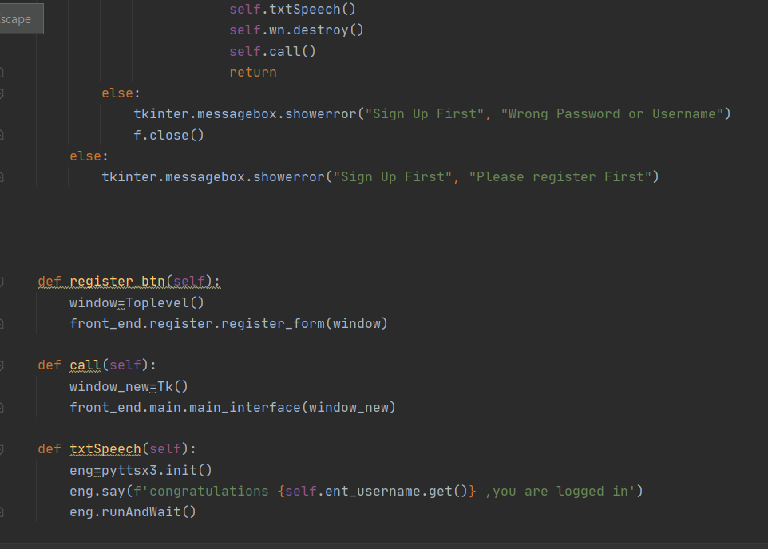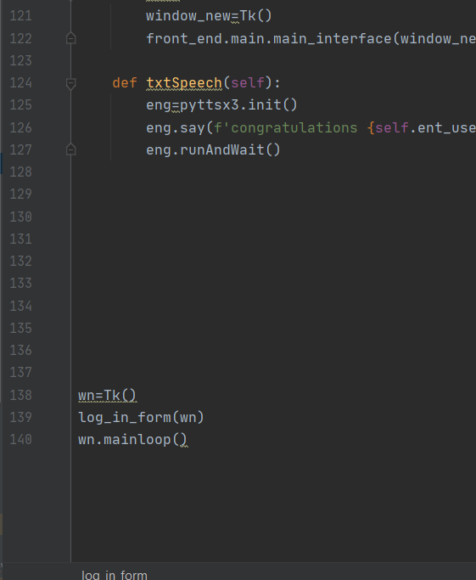

Output: 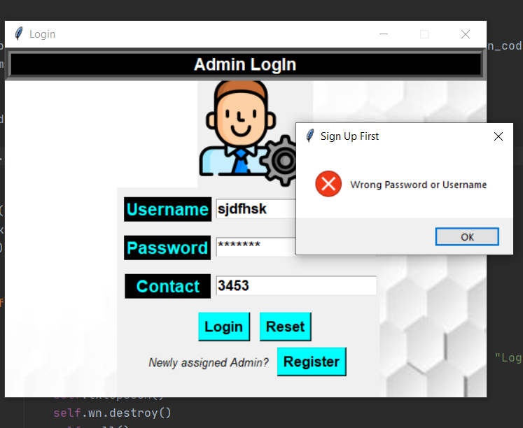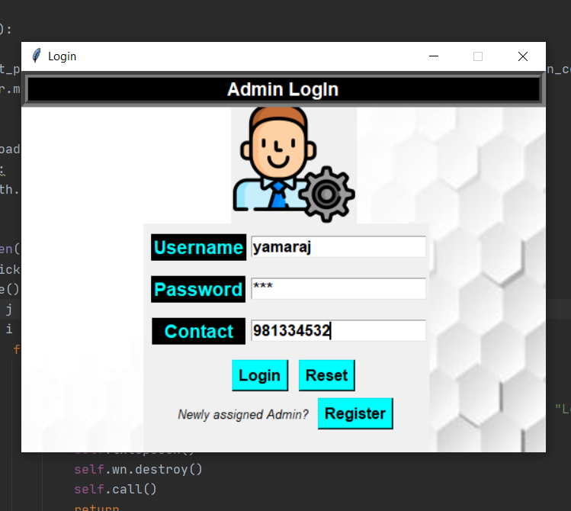

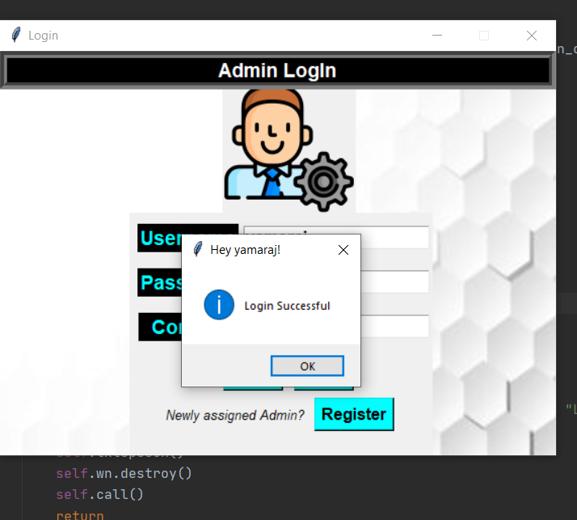

# **Register**

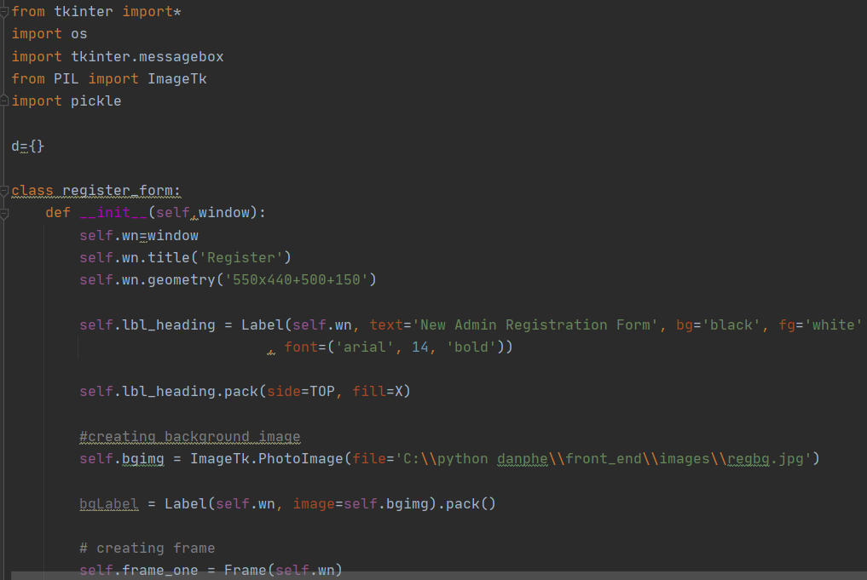

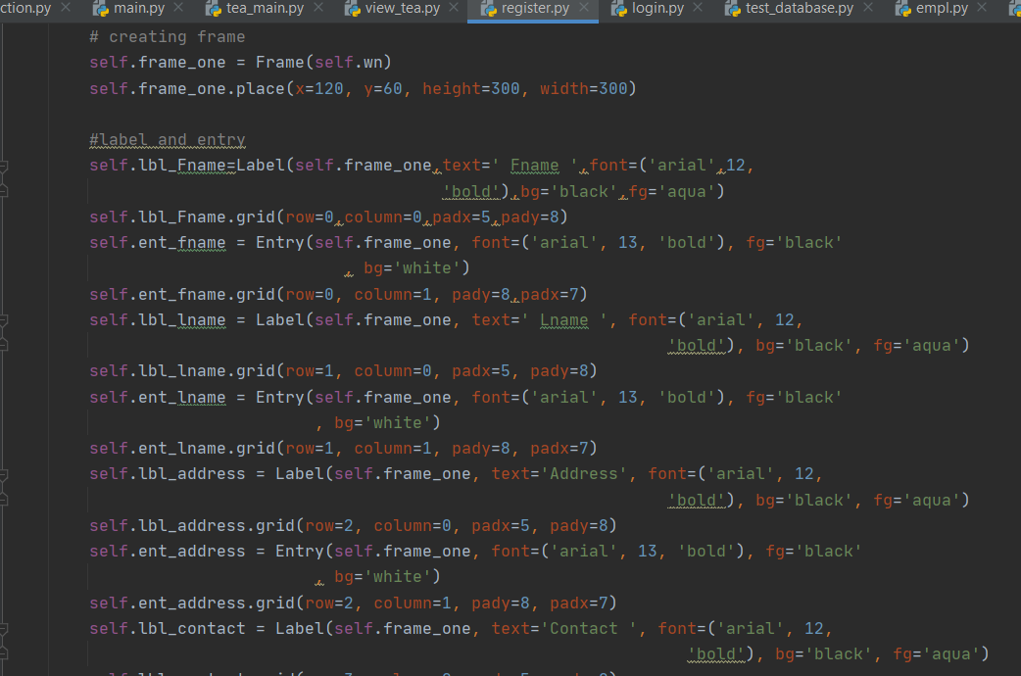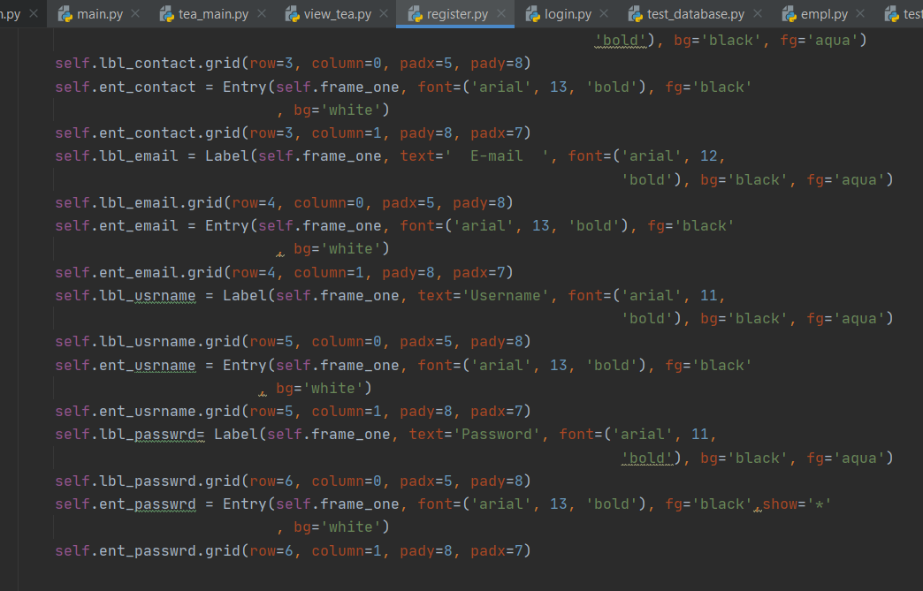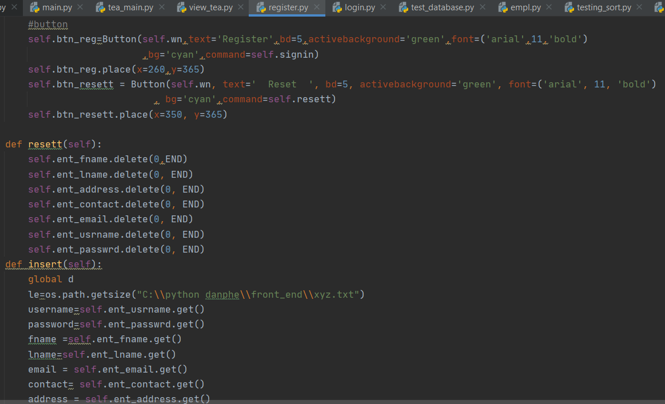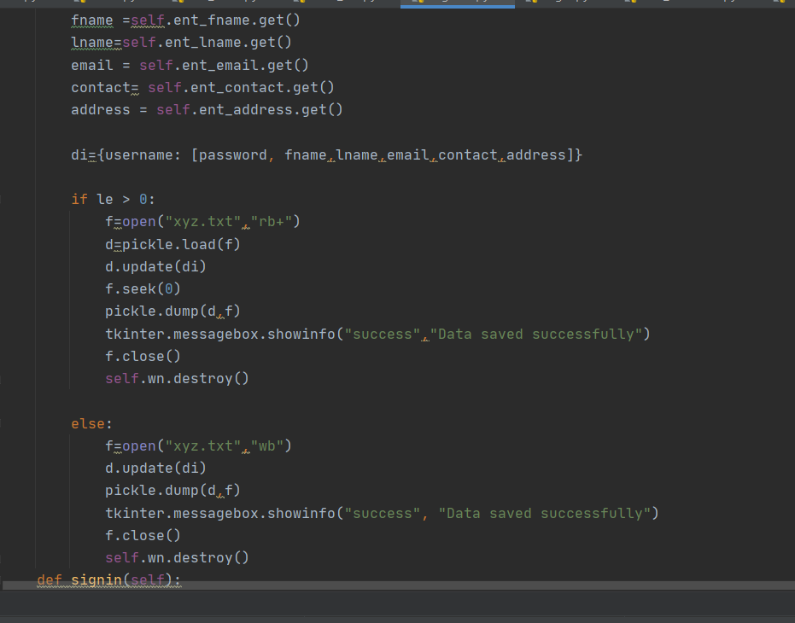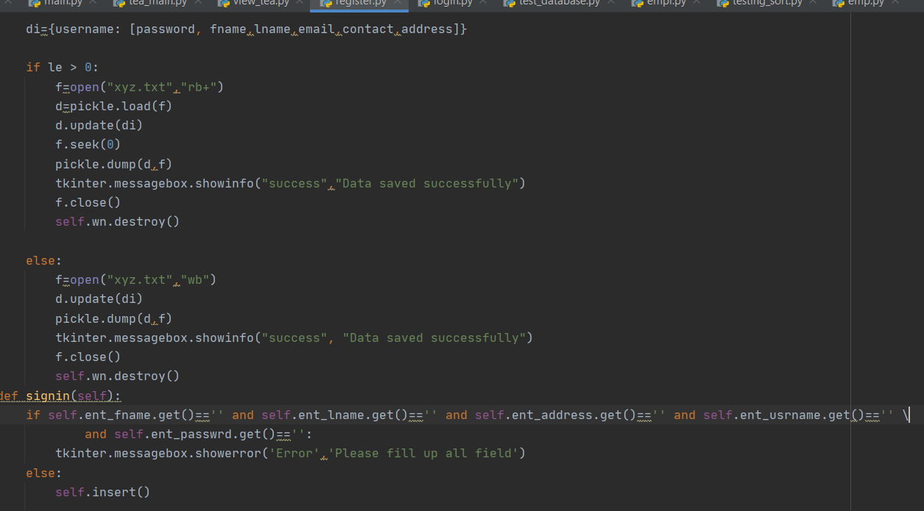

**Output:** 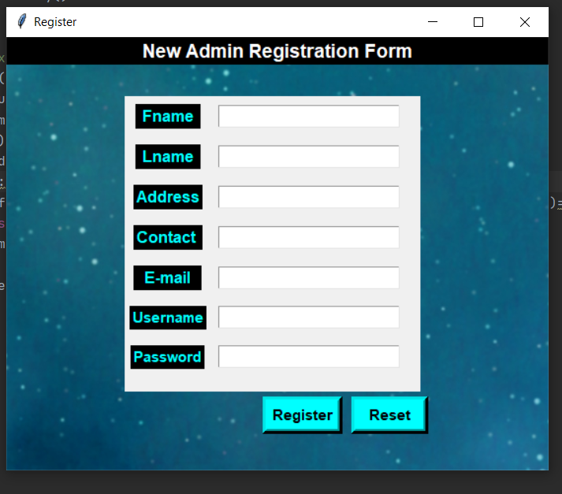

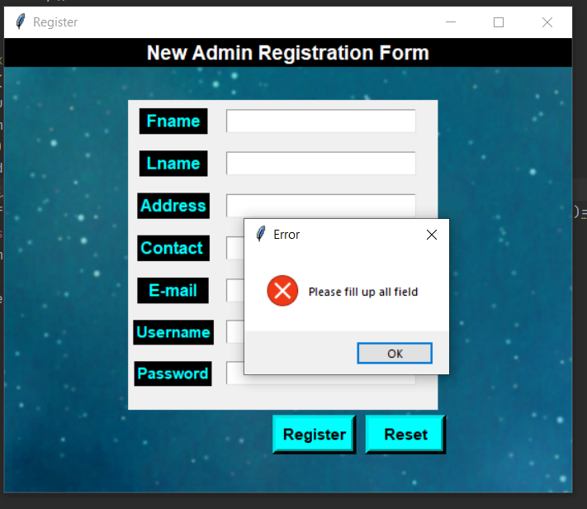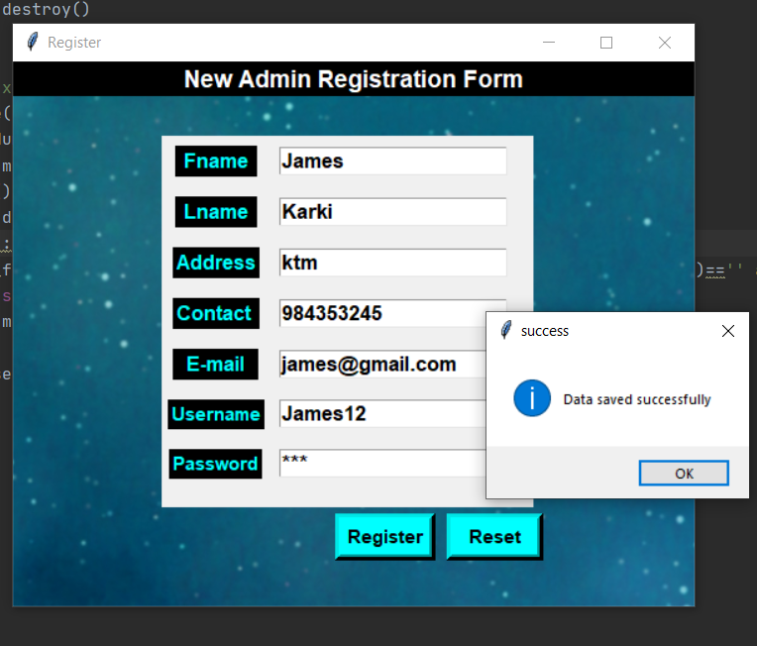

# **Main**

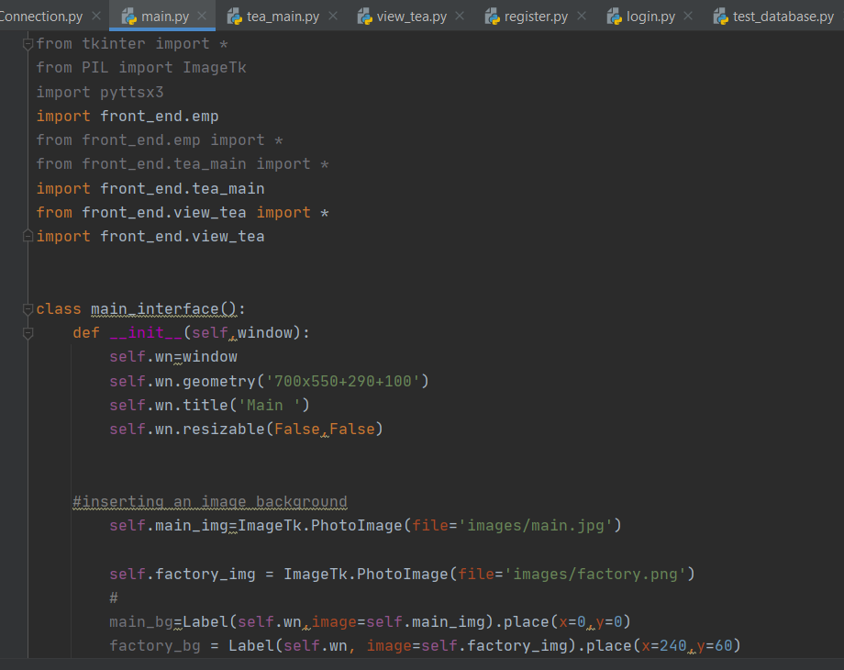

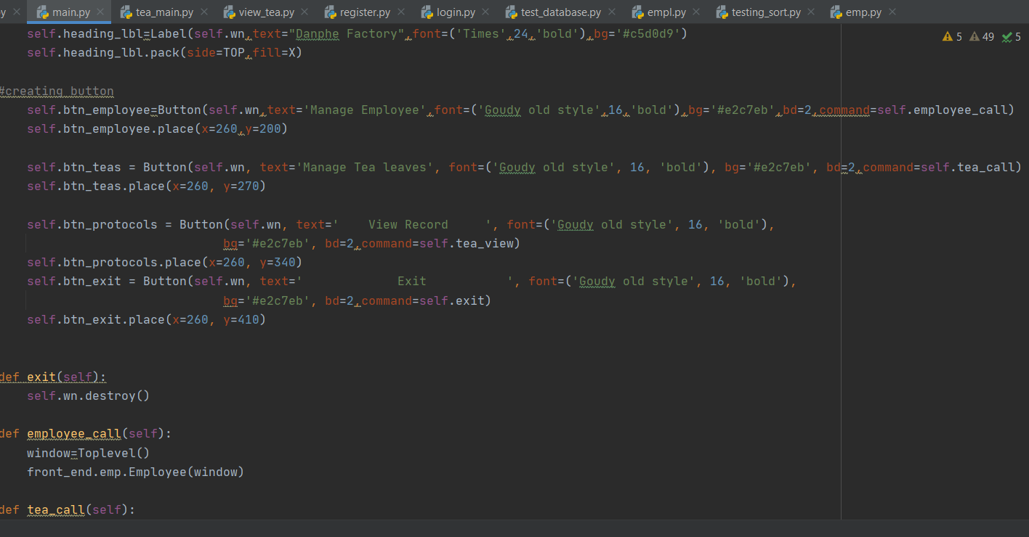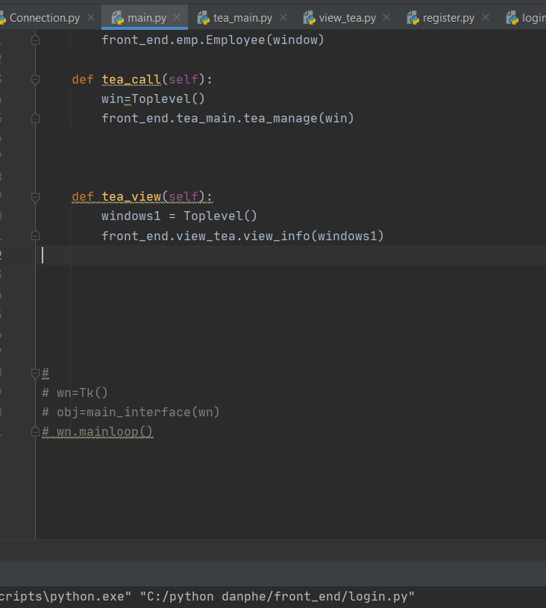

Output

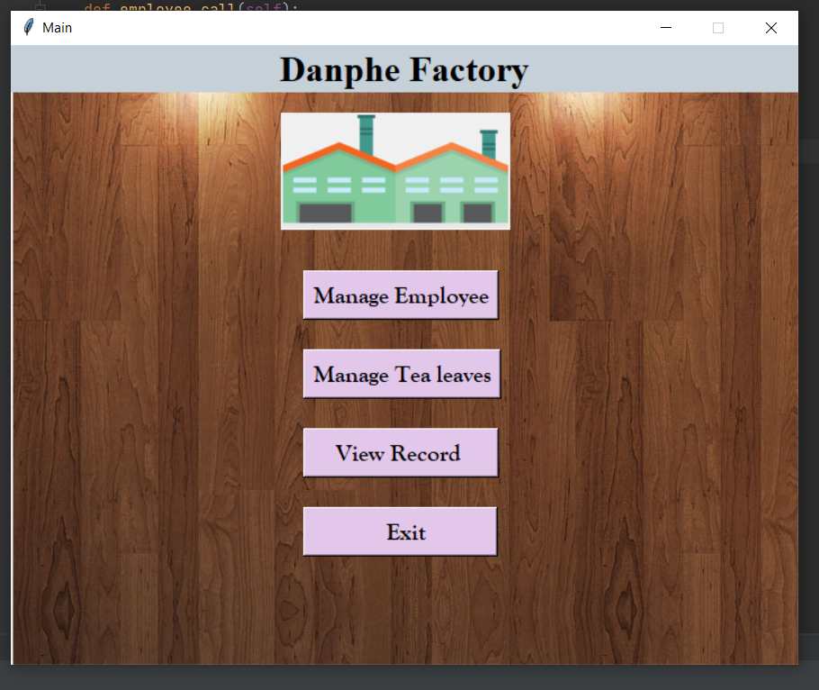

# **Employee:**

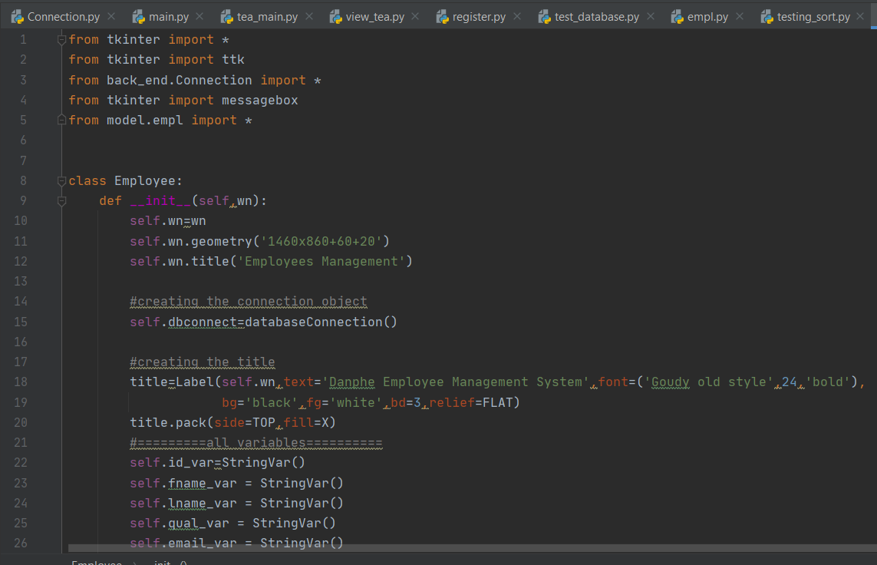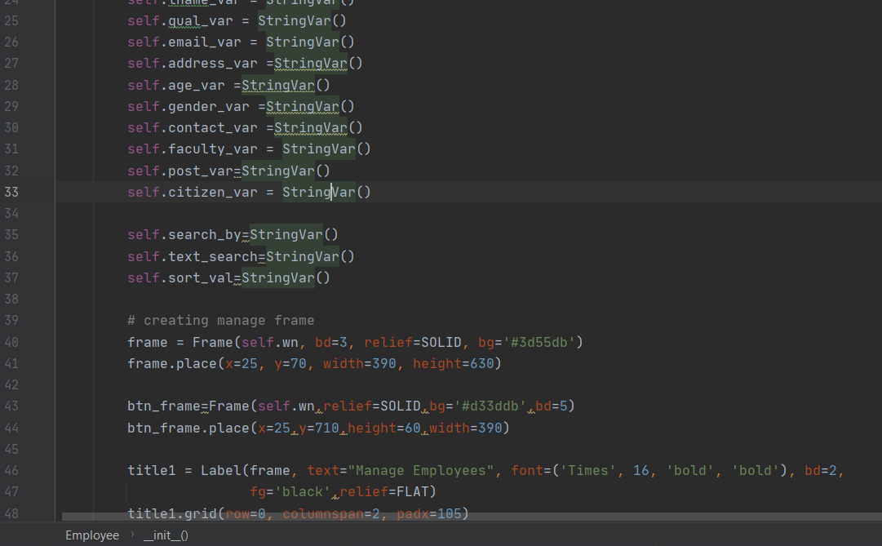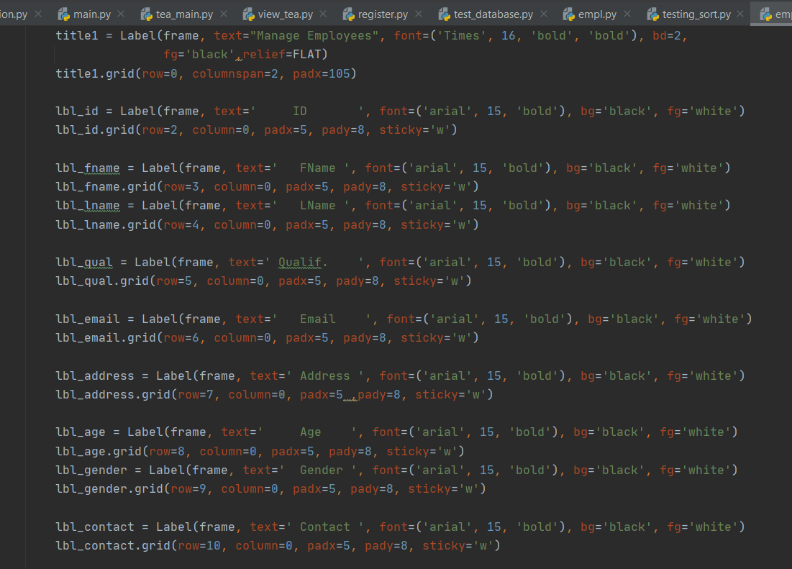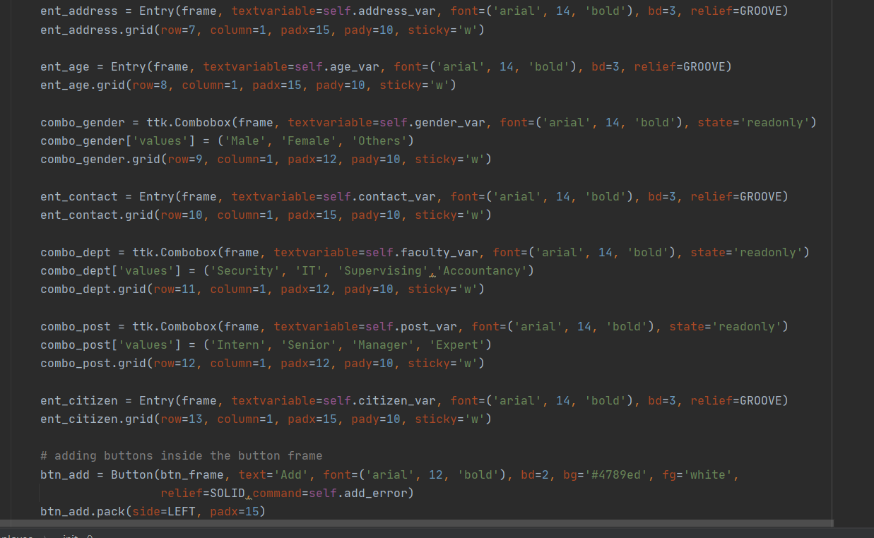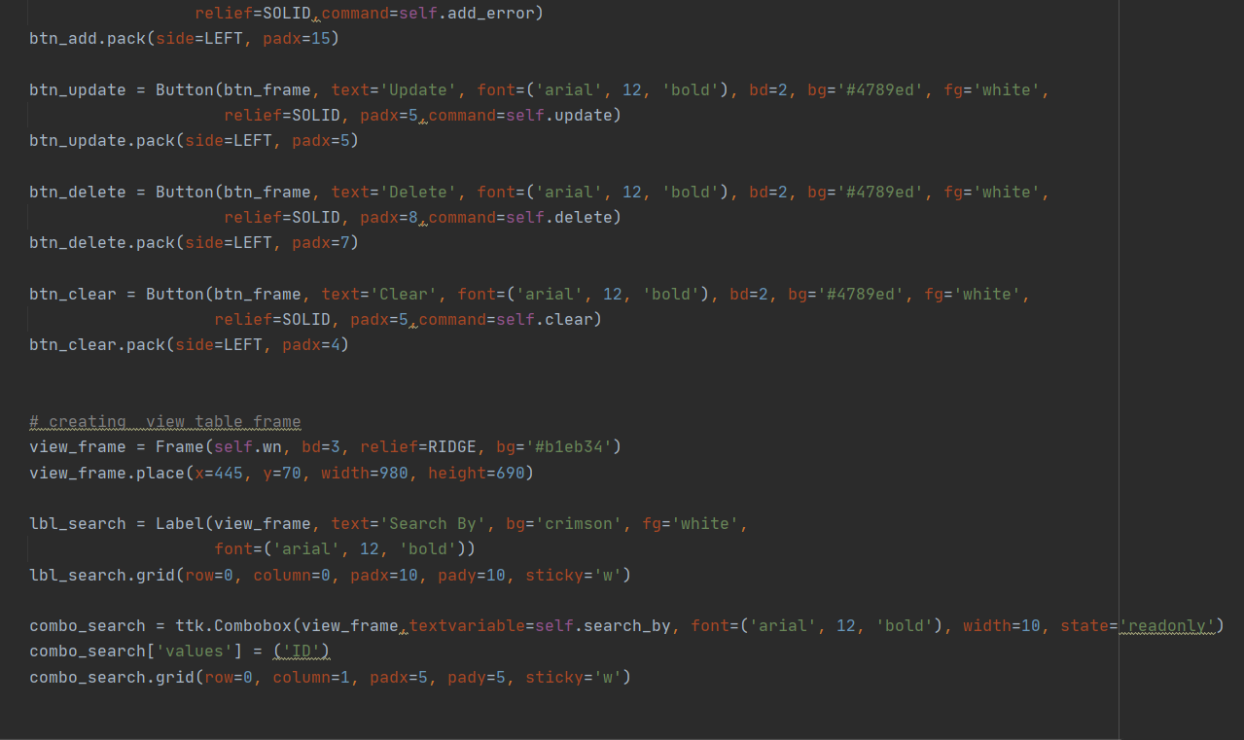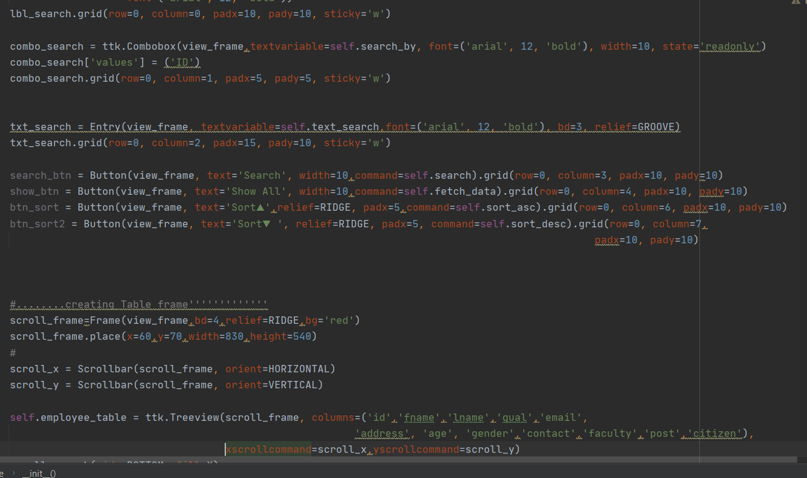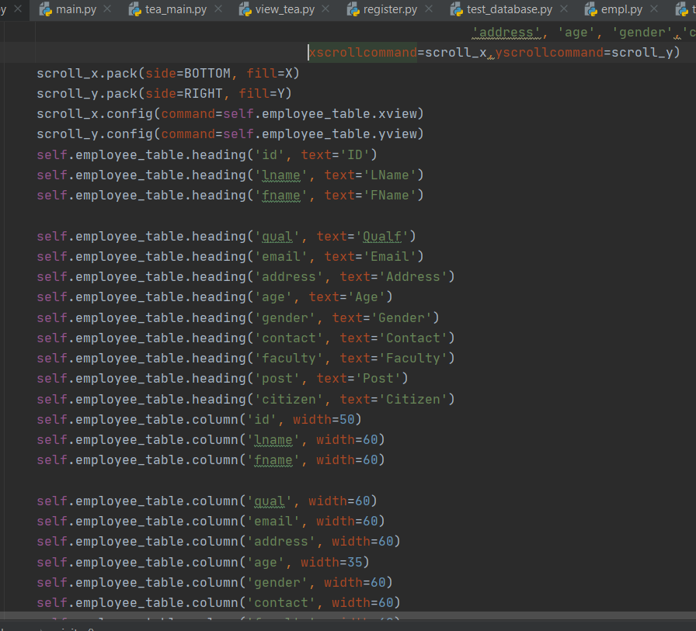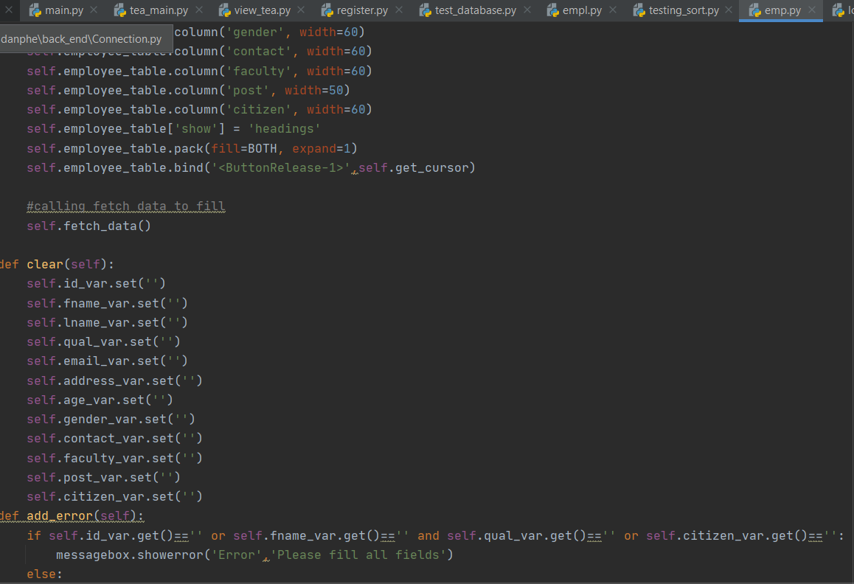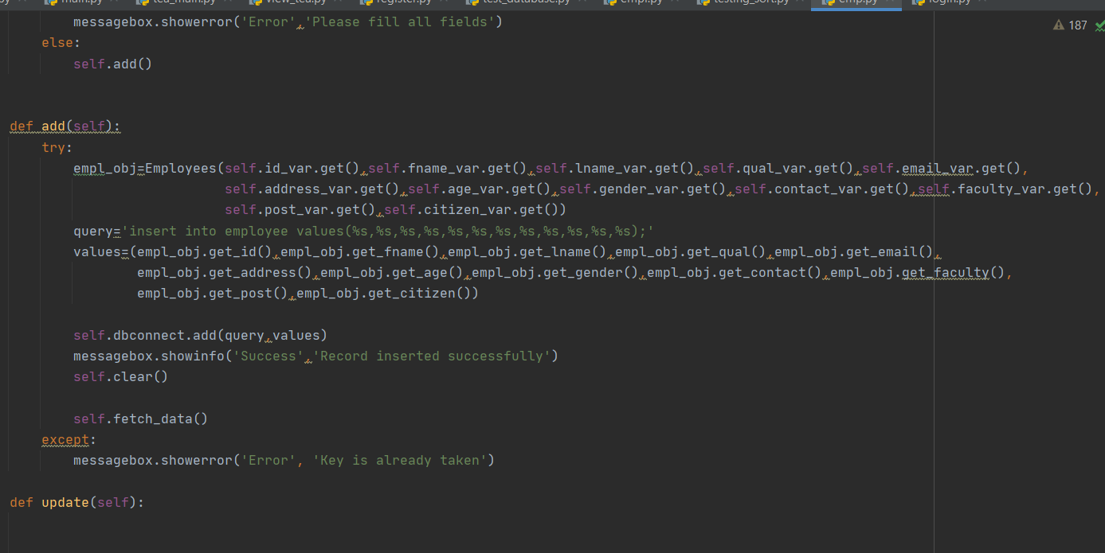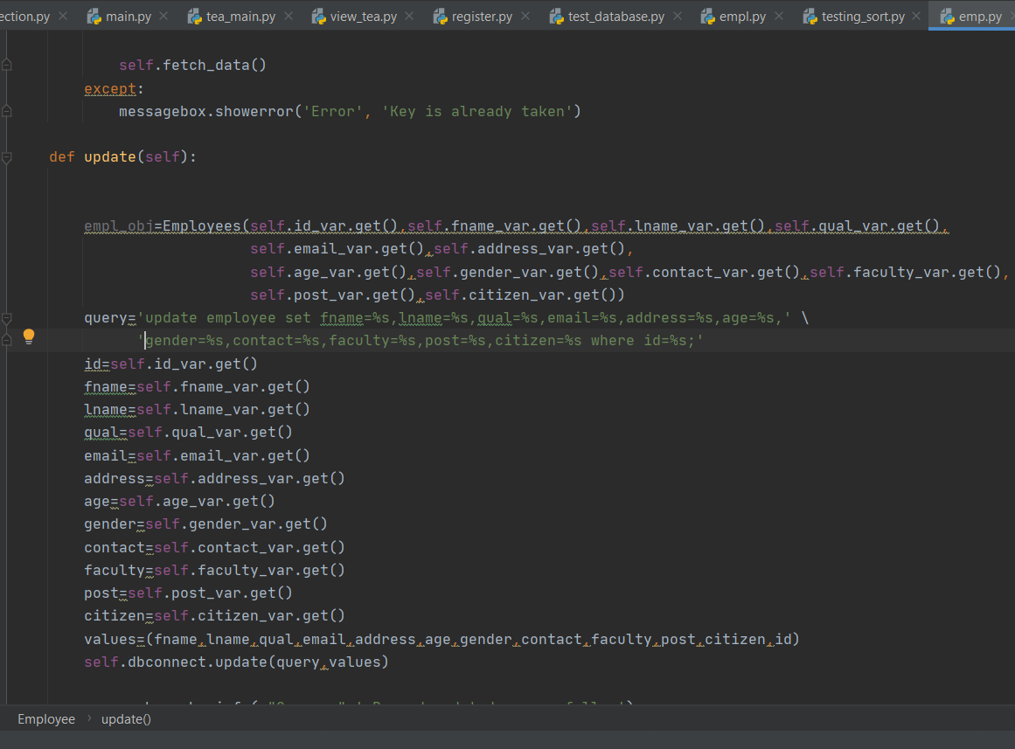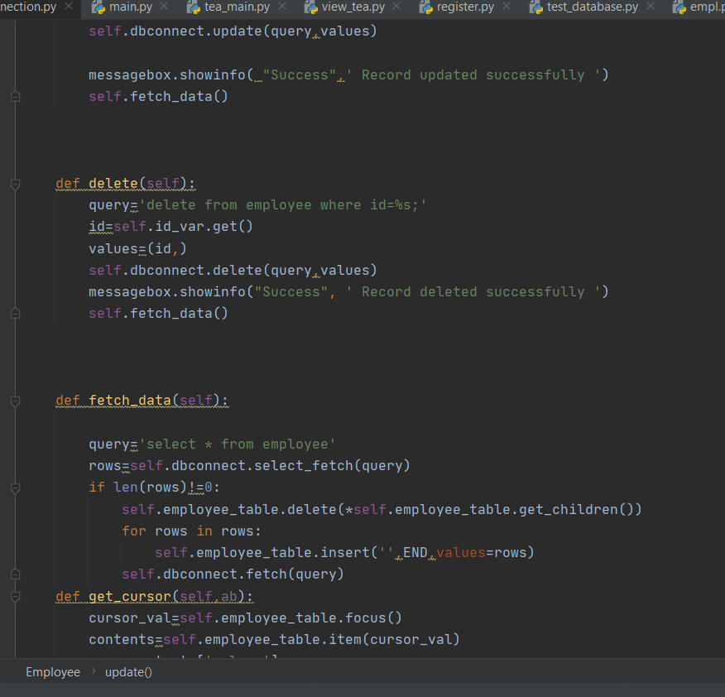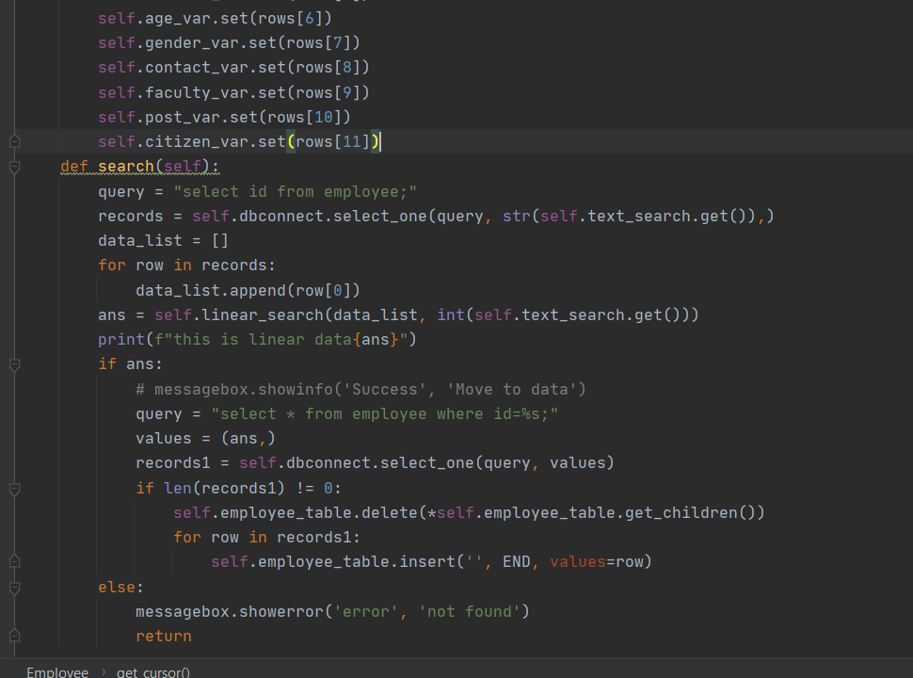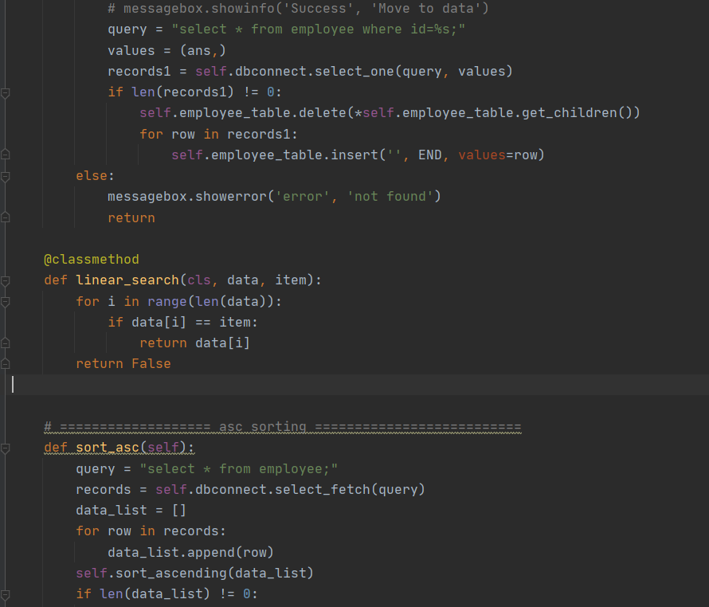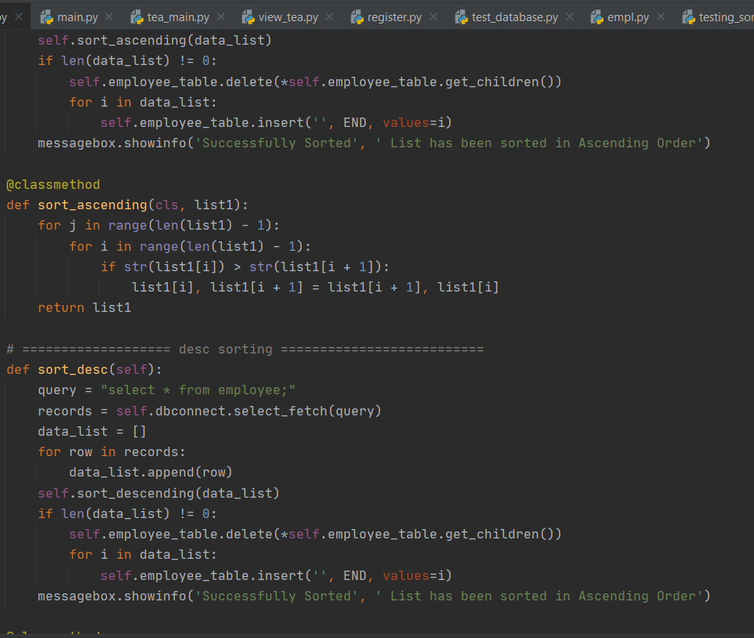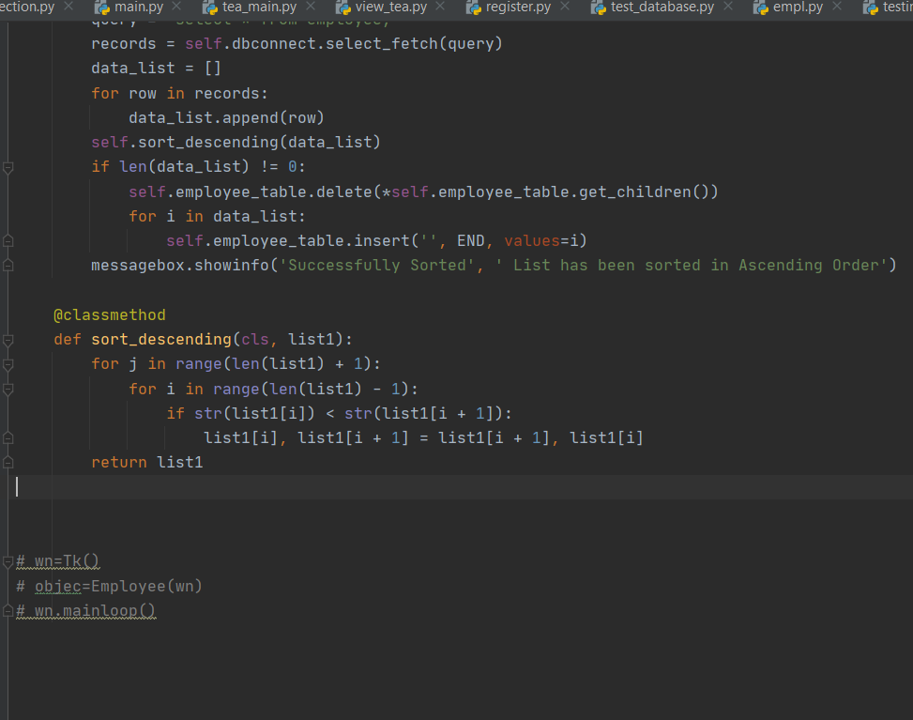

Output

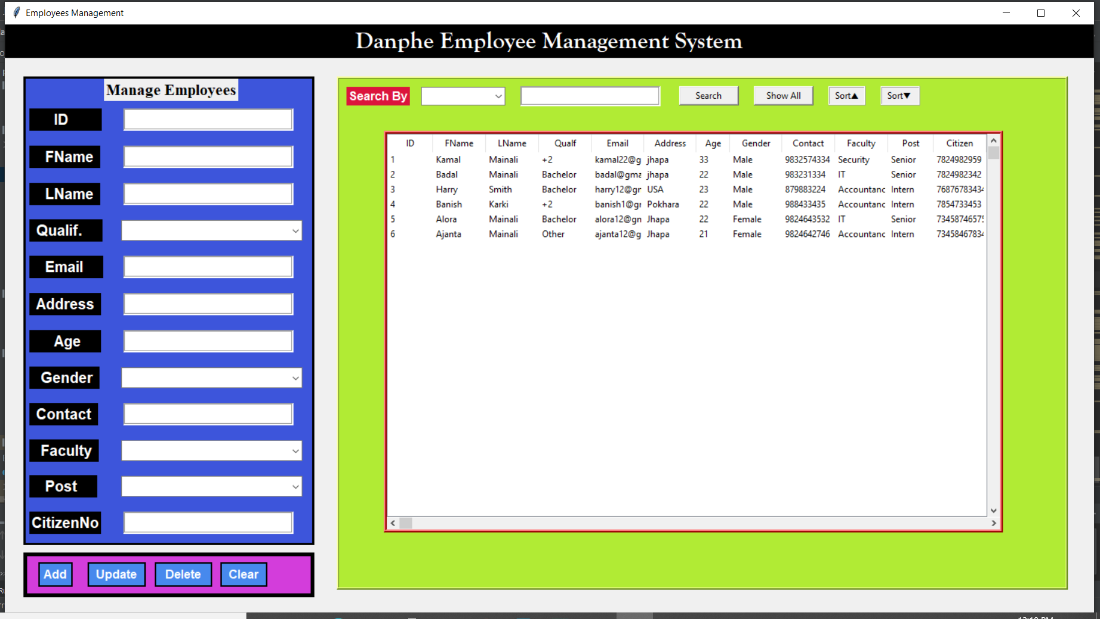

**Tea Main**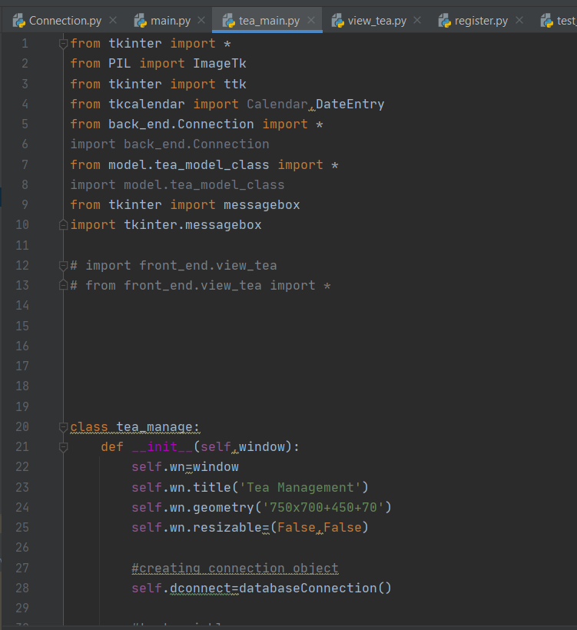

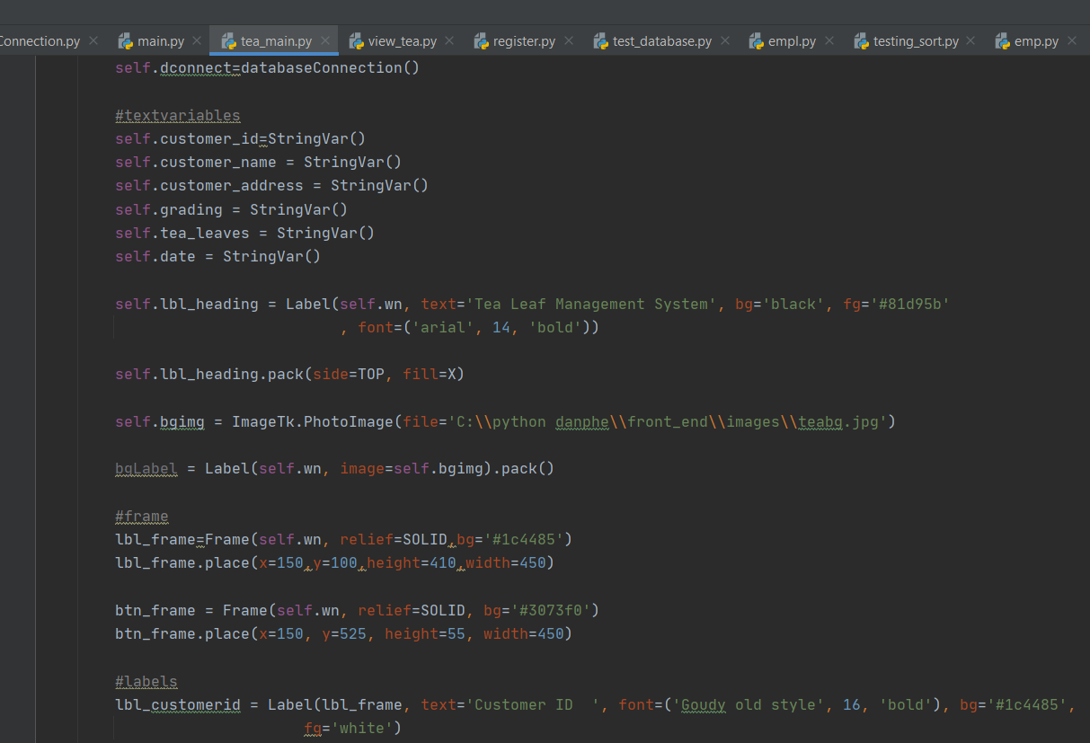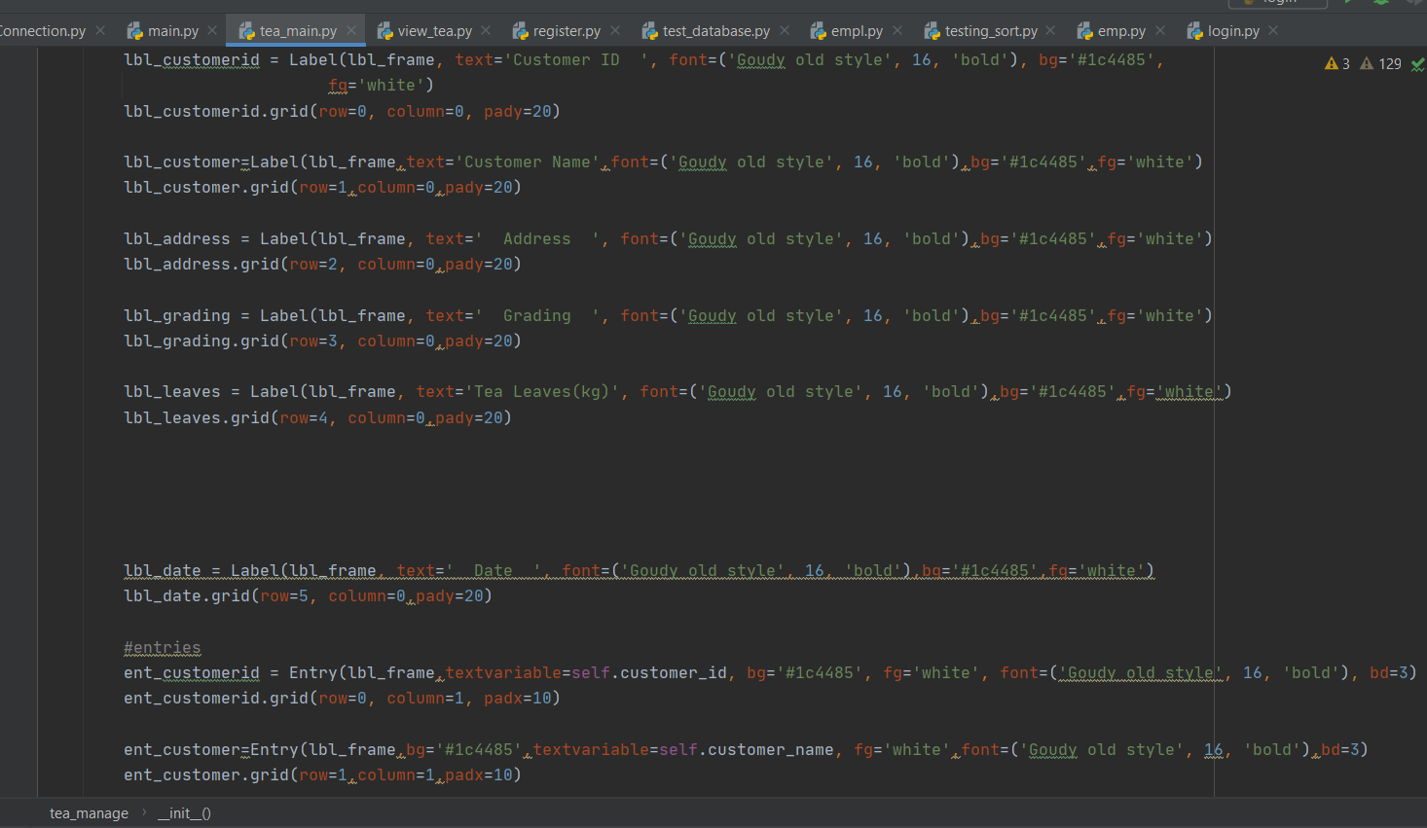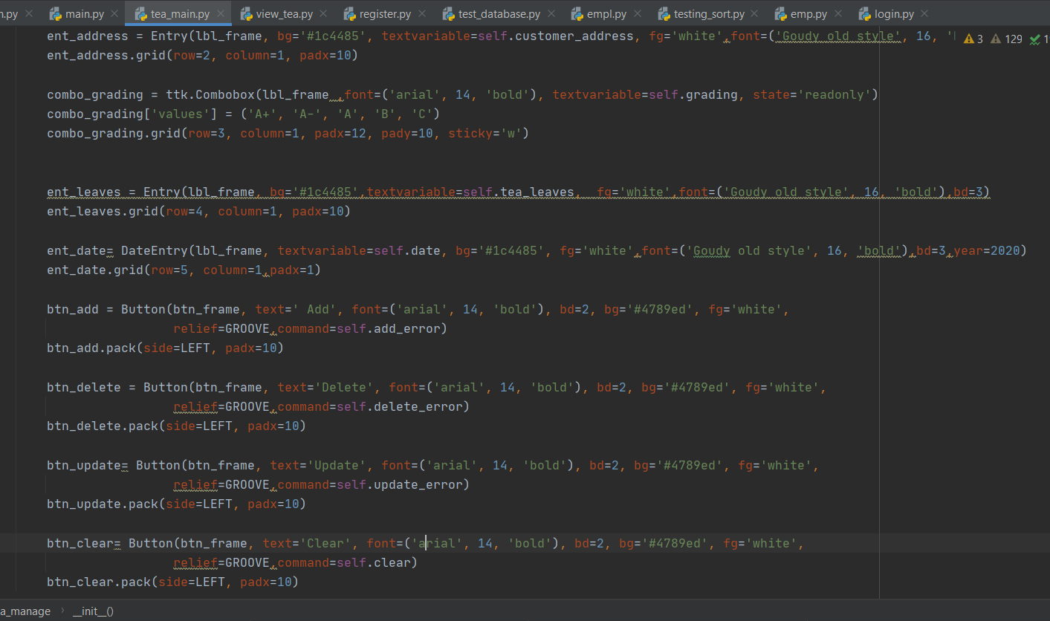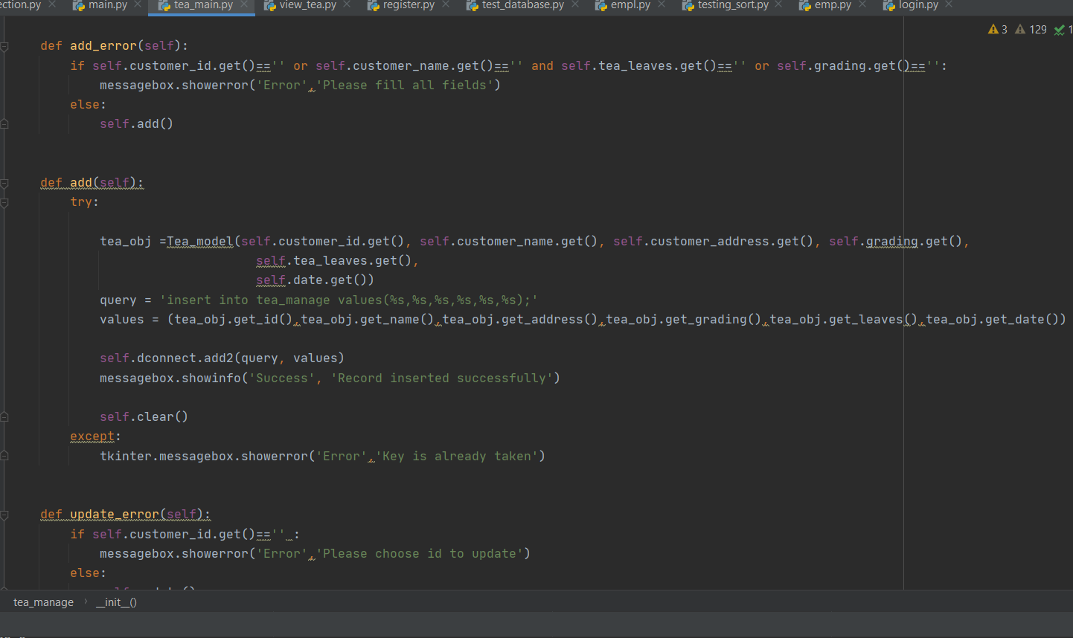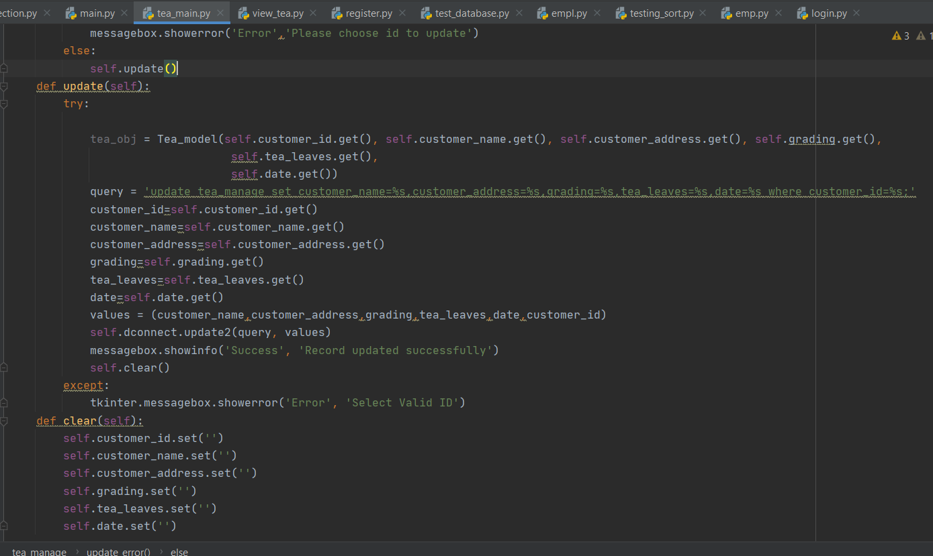

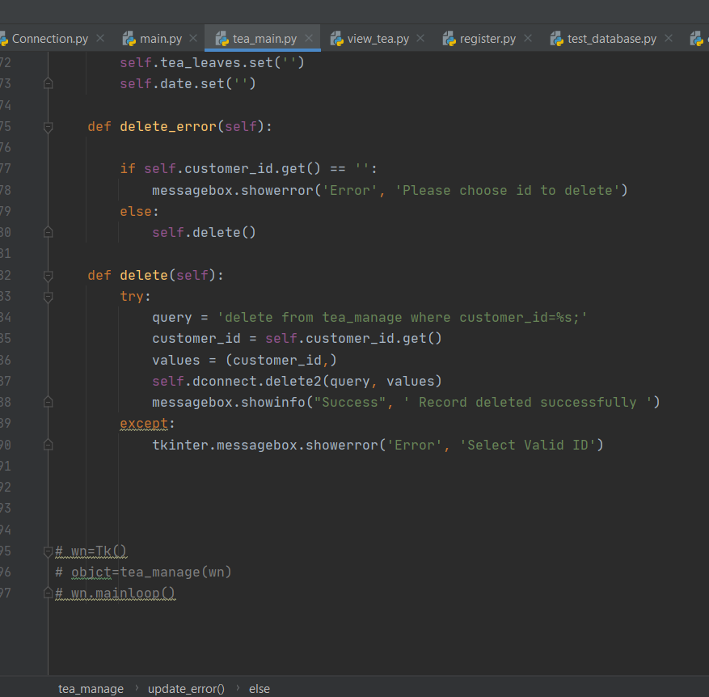

**Output**

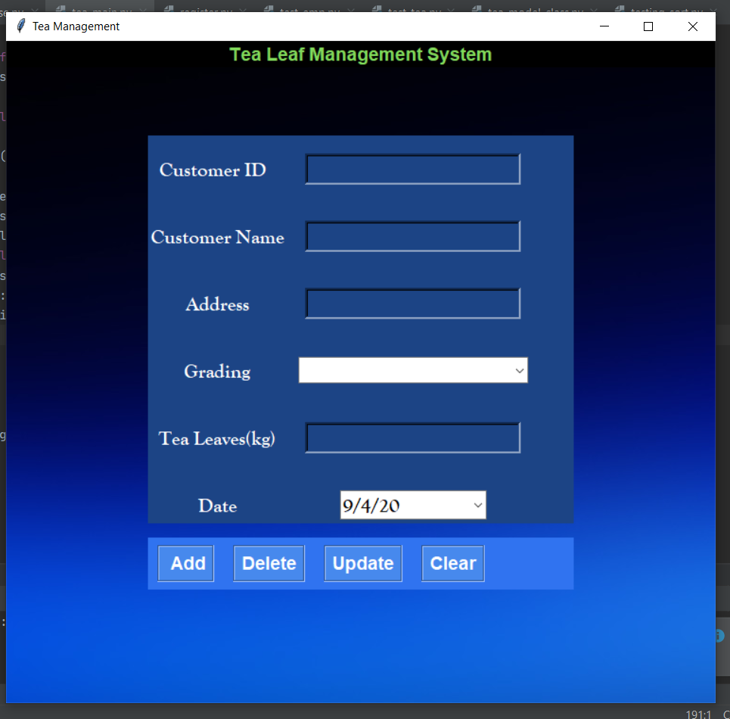

**Tea View Board**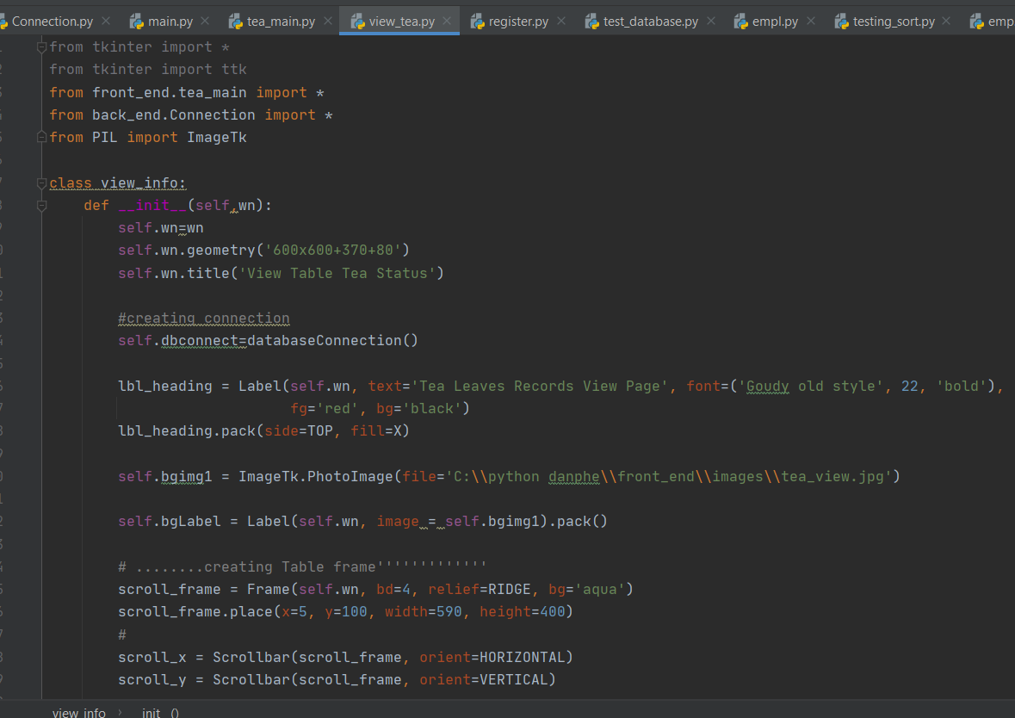

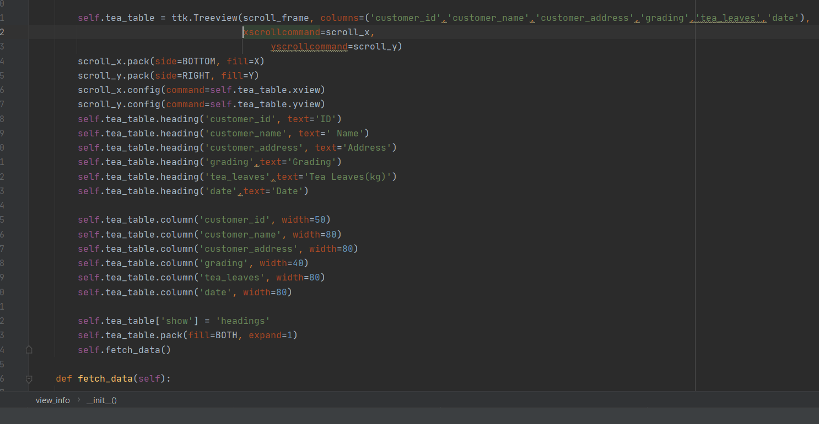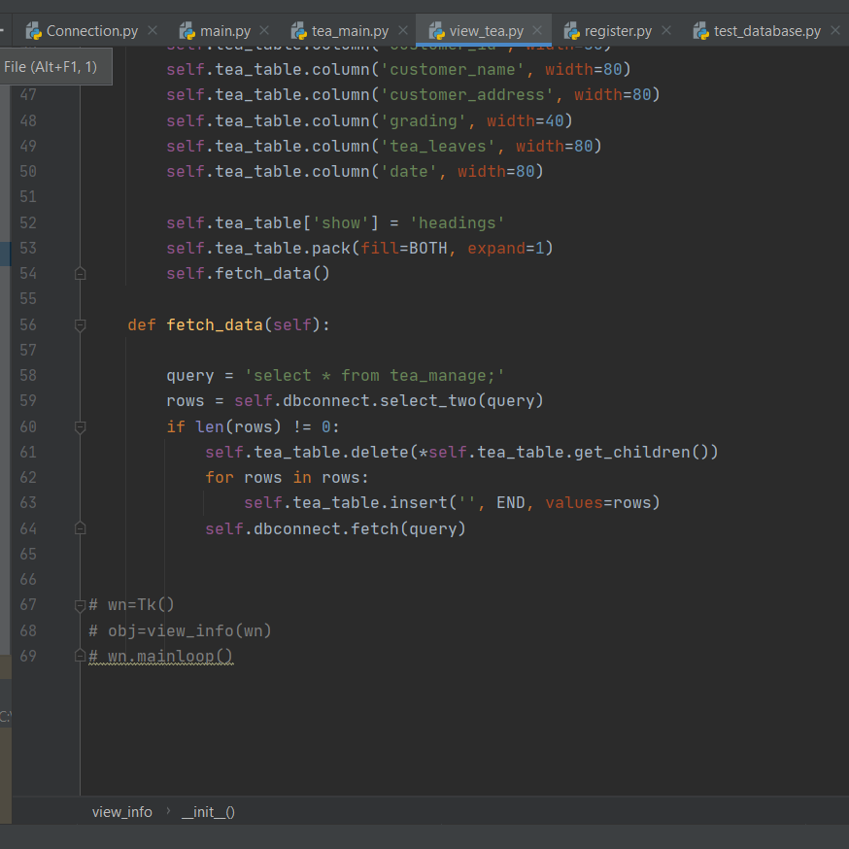

**Output:**

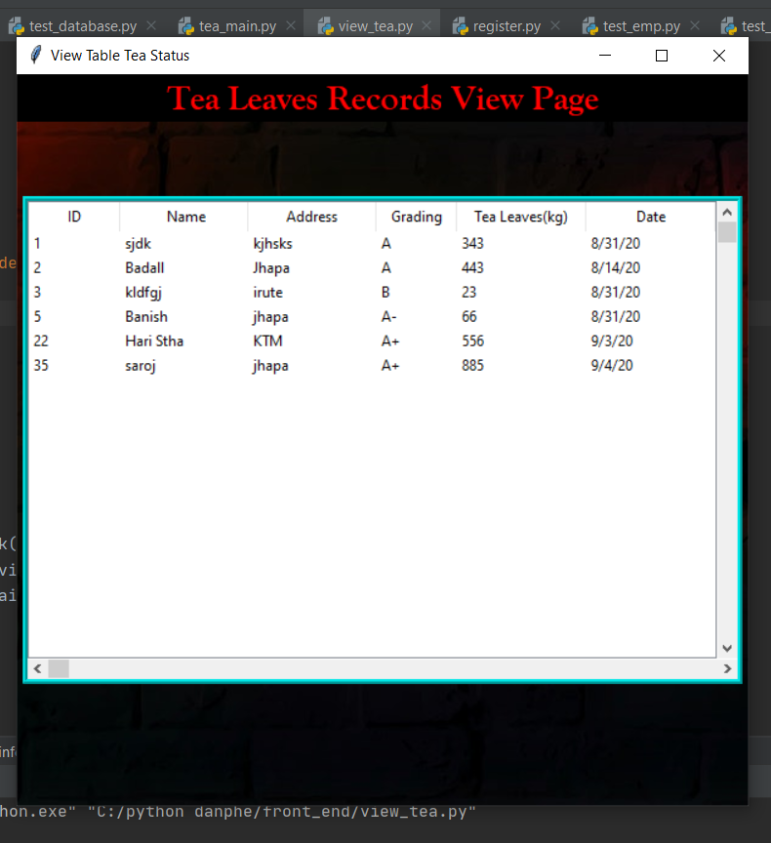

# **Connection**

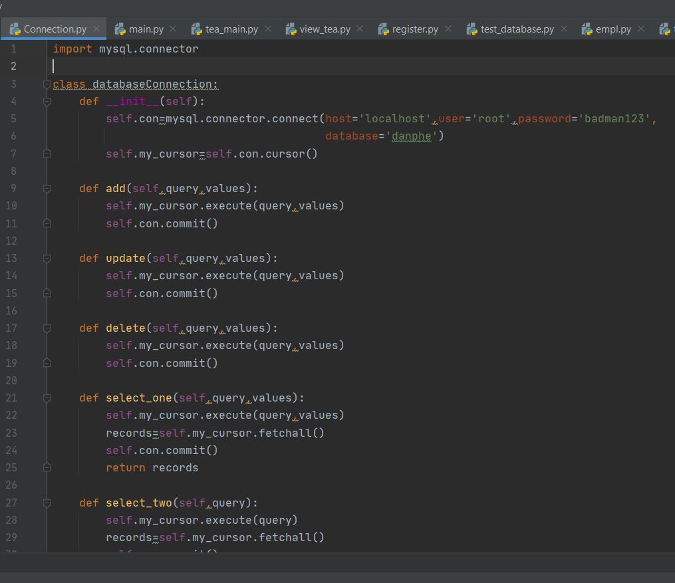

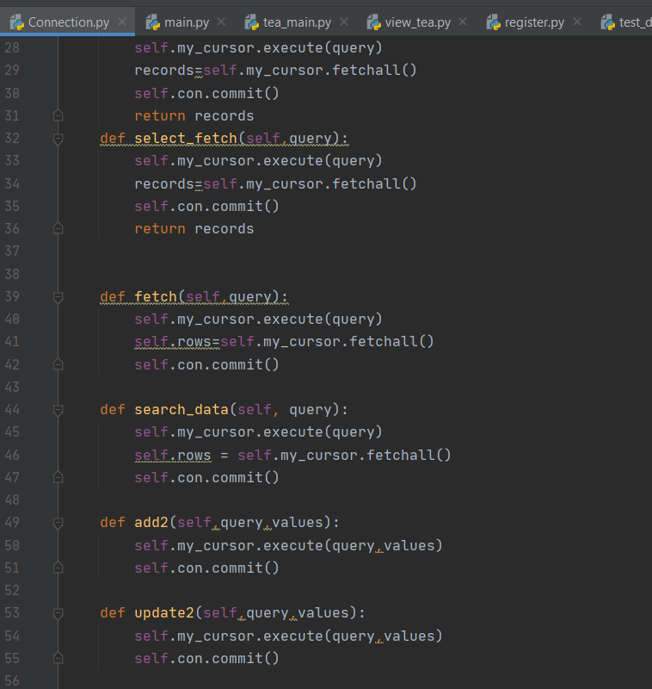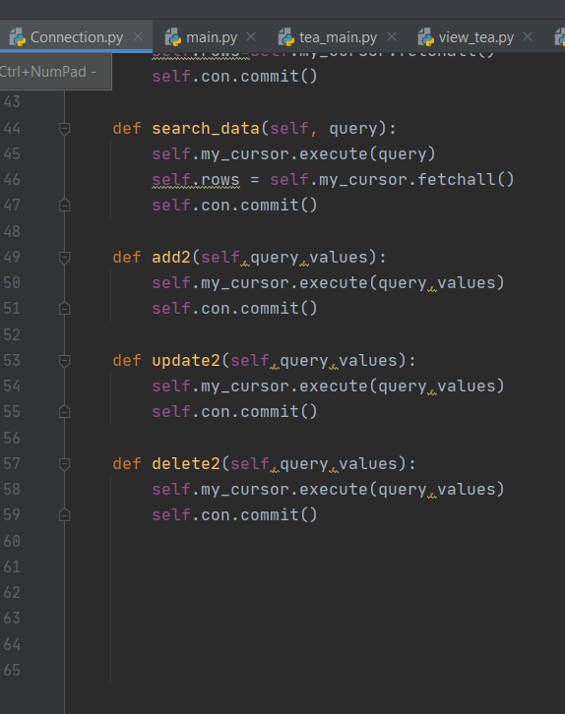

# **Employee Model Class**

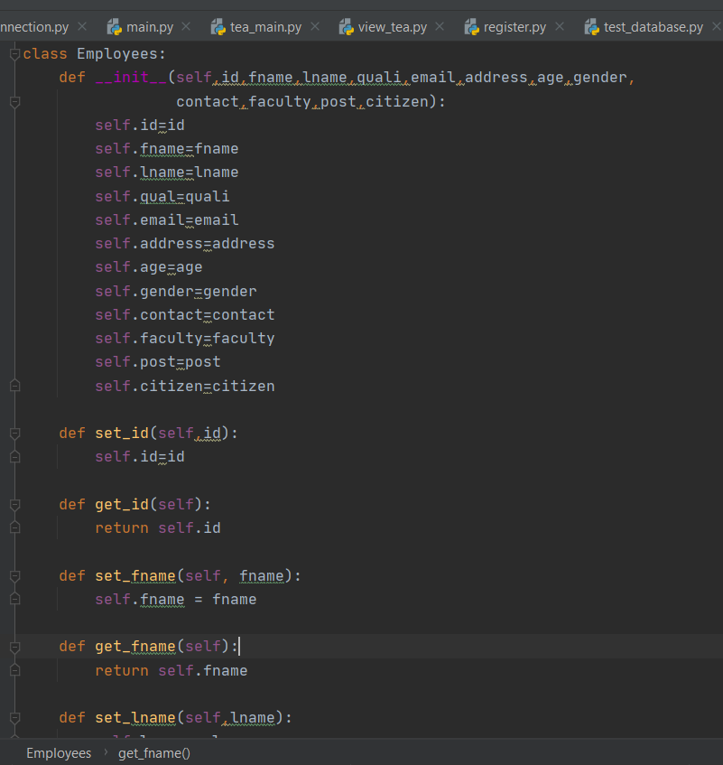

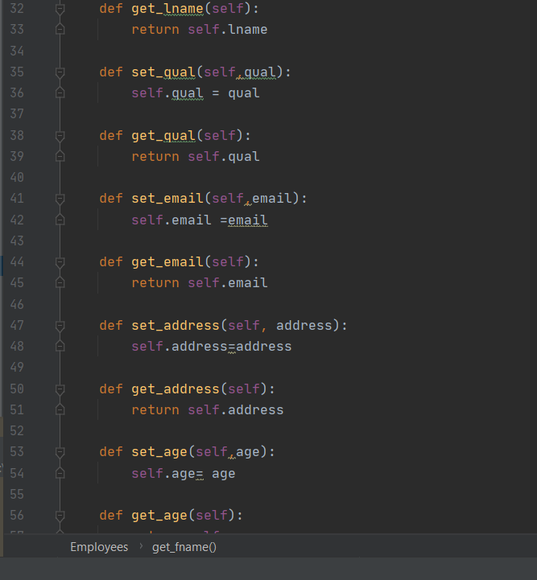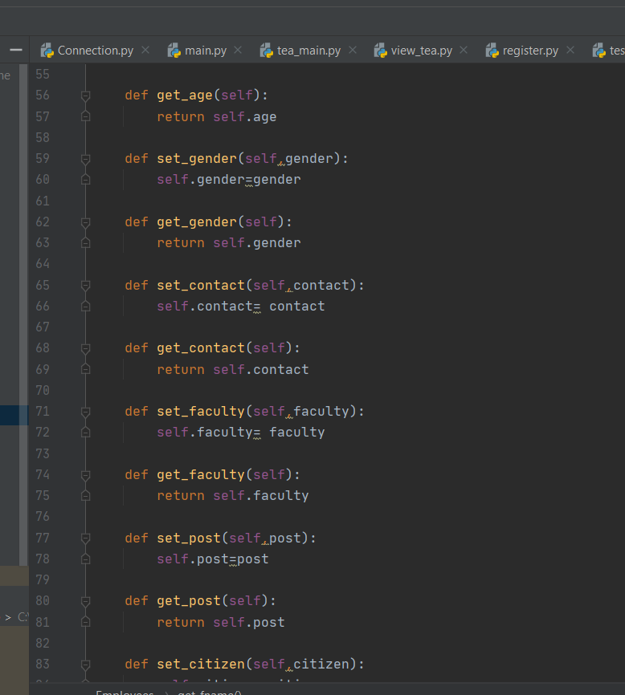

# **Tea Model Class**

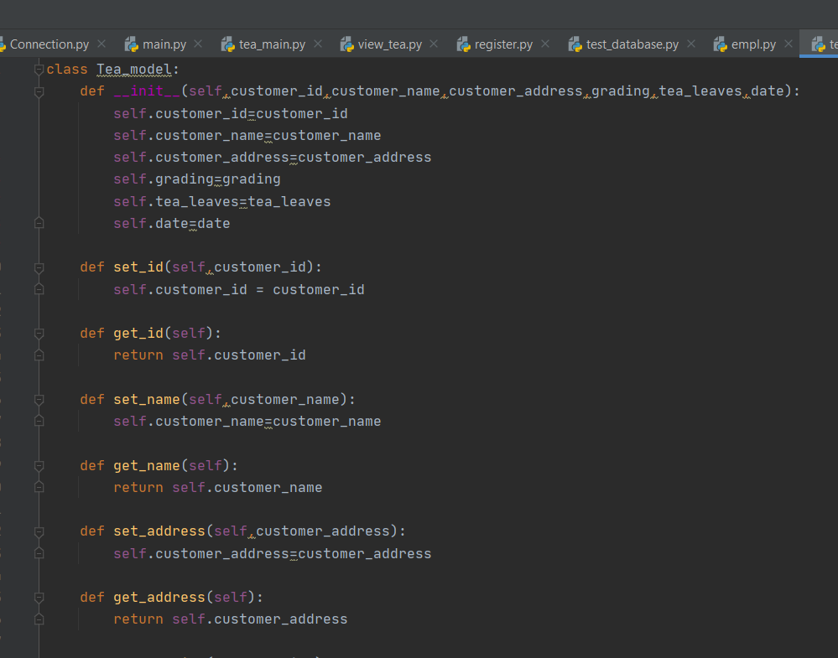

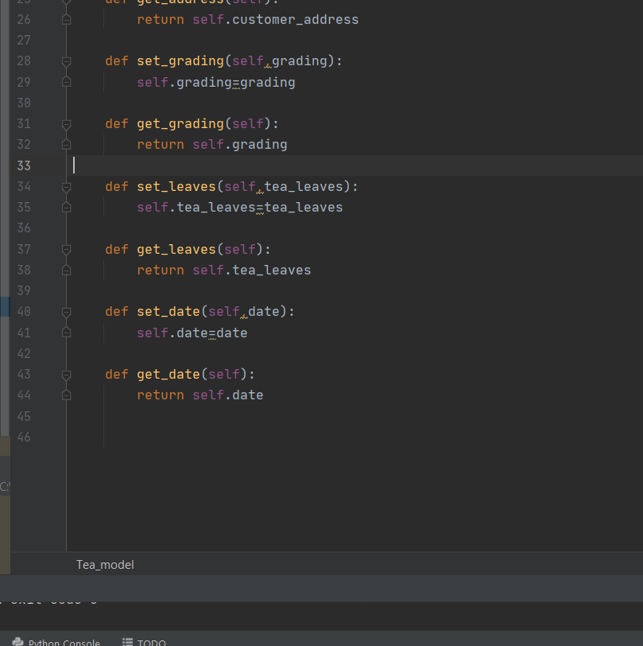

# **Test Employee**

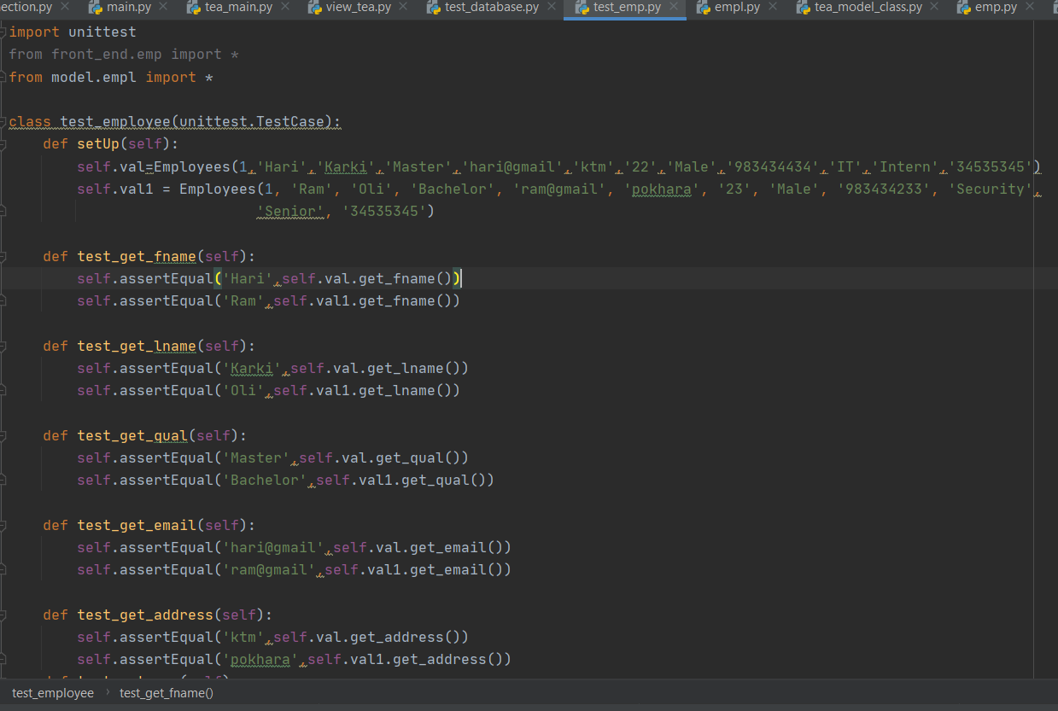

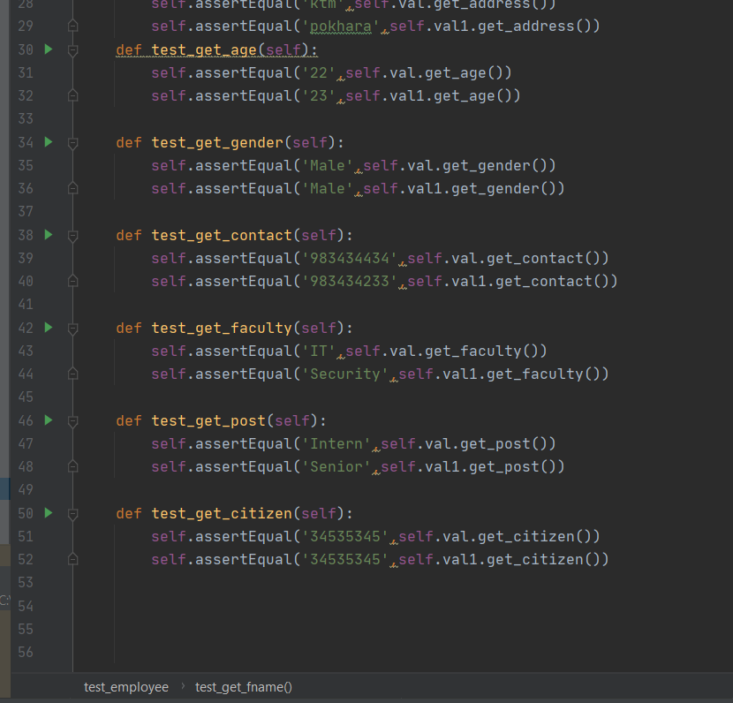

# **Test Tea**

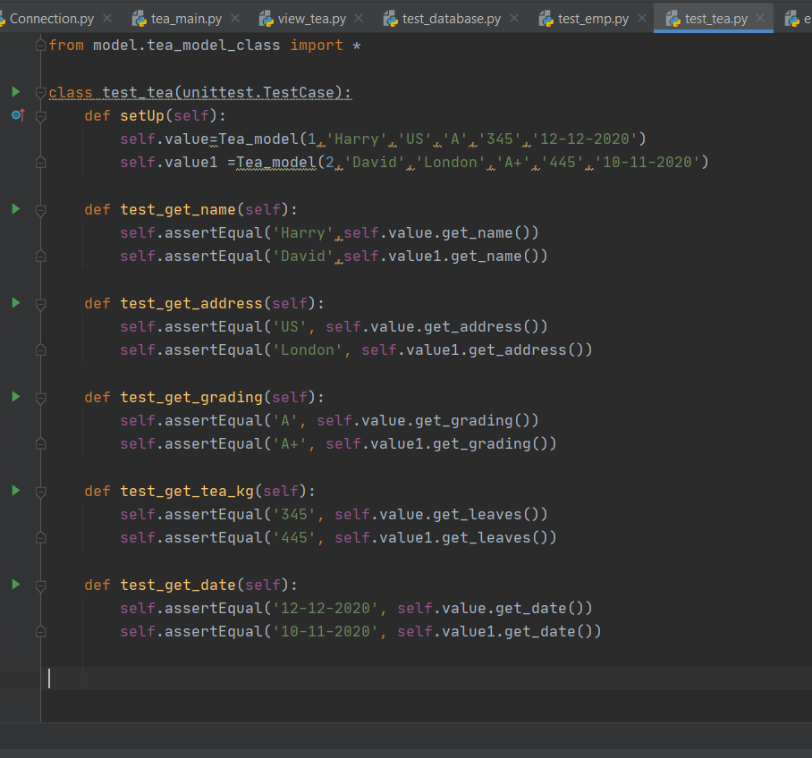

# **Test Database**

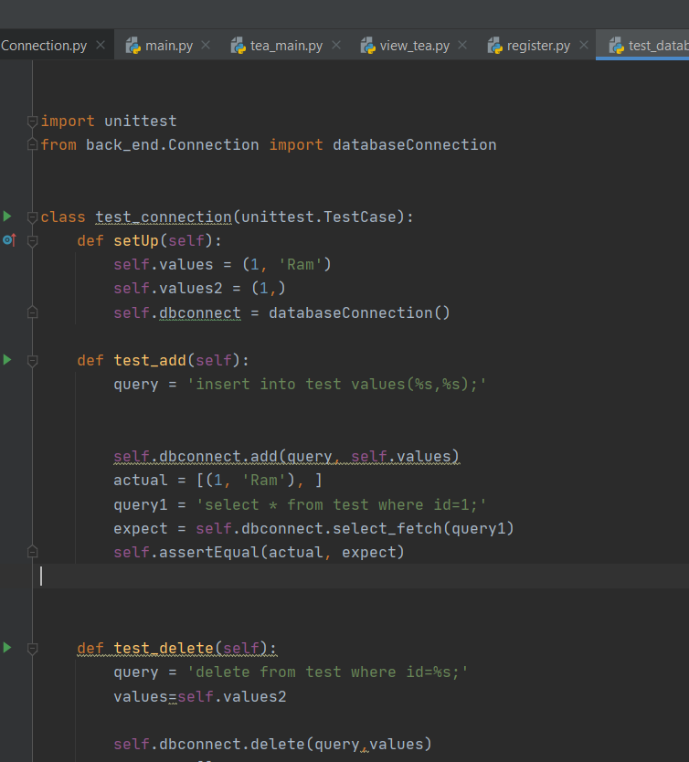

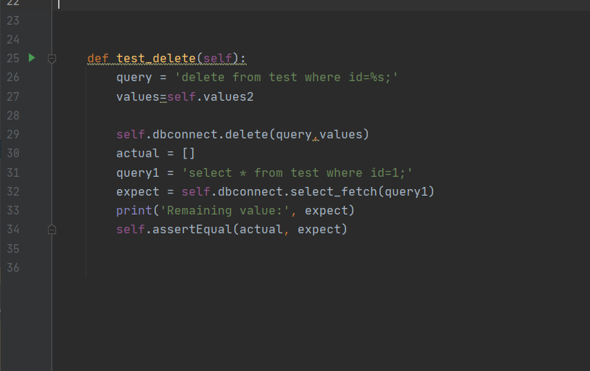

# **Test Sort**

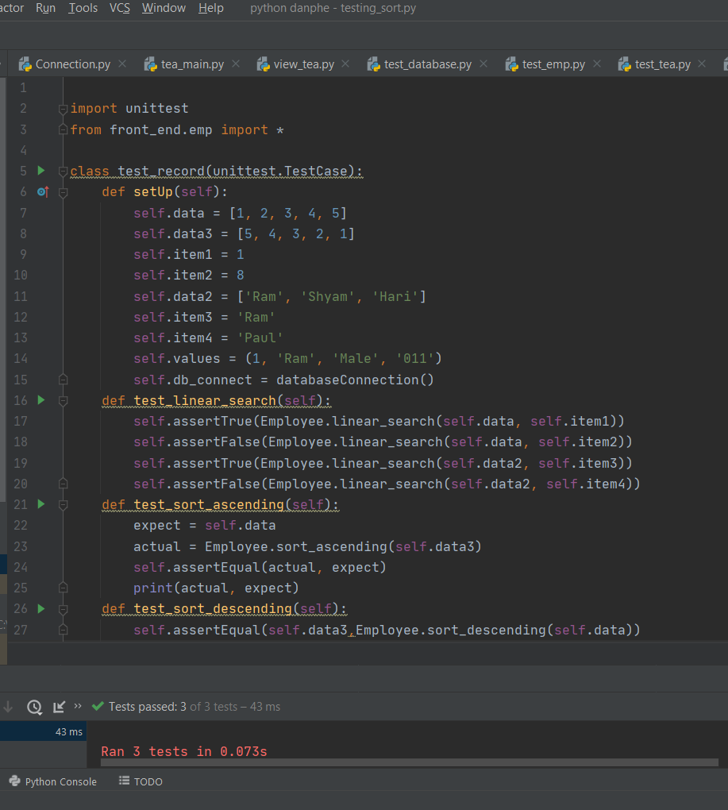

(tutorials point, 2020)

(javatpoint, 2020)

# **Conclusion**

Whole project is now completed and it took around two months. Now it is ready to use for Danphe factory and it contains all the requirements mentioned in the beginning. Error handling is also used for handling the errors and testing is also done for different classes. All testing are passed. Many errors occurred during coding and I got many chance to debug the errors. Application is also converted into executable file so that we could use it in different computers. A proper documentation is also done of given application software.

# **References**

javatpoint, 2020. *Python Tkinter Tutorial - Javatpoint.* [Online]   
Available at: https://www.javatpoint.com/python-tkinter  
[Accessed 03 09 2020].

tutorials point, 2020. *Python - GUI Programming (Tkinter) - Tutorialspoint.* [Online]   
Available at: https://www.tutorialspoint.com/python/python_gui_programming.htm  
[Accessed 2 09 2020].